Task 2: Compilation
CSS Compilation is the process of converting code written in a CSS preprocessor (like Sass, Less, or Stylus) into standard CSS that browsers can understand. Preprocessors provide additional features that enhance regular CSS, but these enhancements need to be compiled into plain CSS before the code is delivered to the browser. This ensures that the final output is fully compatible with all browsers, which only interpret standard CSS.

How CSS Compilation Works with Preprocessors (e.g., Sass or Less)
When using a preprocessor like Sass or Less, you write styles in an extended syntax (with variables, nesting, mixins, etc.). The preprocessor then compiles this syntax into plain CSS. The compiled CSS is what's served to the browser.

Steps Involved in Compiling Sass to CSS
- Install Sass: You need to install Sass on your system. There are various ways to do this, such as using a package manager like npm or installing it as a stand-alone tool.
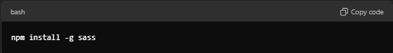
- Write Sass Code: Write your styles in a .scss or .sass file using the extended features that Sass provides.
- Compile Sass to CSS: Run the Sass compiler on your .scss or .sass file to generate the corresponding .css file. This is done via the command line, a build tool (like Gulp or Webpack), or an integrated development environment (IDE) extension.
Example command for compiling a Sass file:
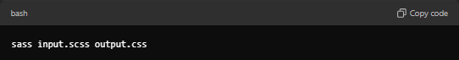
This will take your input.scss file and convert it into a standard output.css file.
- Include Compiled CSS in Your Project: Once compiled, you can link the output CSS file in your HTML or use it as you would any other CSS file.

Example of Sass Code and Compiled CSS

Original Sass Code (input.scss)
// Define variables
$primary-color: #3498db;
$text-color: #2c3e50;
$padding: 10px;

// Define a mixin for button styles
@mixin button-style($bg-color) {
padding: $padding;
background-color: $bg-color;
border-radius: 5px;
color: white;
}

// Use variables and mixins
body {
background-color: $primary-color;
color: $text-color;
}

.button {
@include button-style($primary-color);
}

.alert {
@include button-style(#e74c3c);
}

Compiled CSS (output.css)
/* Compiled CSS */
body {
background-color: #3498db;
color: #2c3e50;
}

.button {
padding: 10px;
background-color: #3498db;
border-radius: 5px;
color: white;
}

.alert {
padding: 10px;
background-color: #e74c3c;
border-radius: 5px;
color: white;
}

Key Differences Between Sass Code and Compiled CSS:
- Variables: In Sass, you can define variables (e.g., $primary-color), but these are converted into static values in the compiled CSS.
- Nesting: The nesting of selectors in Sass reflects the structure of the HTML, but this is flattened into regular selectors in the compiled CSS.
- Mixins: Mixins are used to reuse code (like the button styles), but once compiled, the mixin is expanded and applied in the CSS.

Tools for Compiling Sass:
- Command Line: You can use the sass command directly.
- Build Tools: Gulp, Webpack, Grunt, etc., often automate the compilation process.
- IDE Extensions: Many IDEs (e.g., VS Code, WebStorm) have extensions to watch and automatically compile .scss files.
- Sass Watch: Sass can watch files for changes and automatically compile them when modifications are detected:
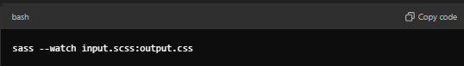

Benefits of Compilation in CSS Preprocessors:
- Performance: Browsers only load compiled CSS, avoiding performance issues caused by dynamic processing.
- Efficiency: Developers can write more concise, maintainable styles and let the preprocessor handle the repetitive, verbose aspects of CSS.
- Error Checking: Preprocessors provide error checking and warnings, which help catch mistakes before the CSS is served to the browser.

